Brain Tumor Detection in MRI Using Deep Learning
Parva Kumarpal Shah
Department of Computer Science
Vellore Institute of Technology, Chennai

2. Abstract

Diagnosing brain tumors from MRI scans is genuinely difficult work — it takes a long time, depends heavily on the radiologist's experience, and mistakes do happen. Older machine learning approaches required a lot of manual feature engineering, and while deep learning avoids that, it tends to overfit when training data is limited (which is almost always the situation in medical imaging). This project builds CNN-based models for brain tumor detection and classification. The approach brings together transfer learning, ensemble learning, hyperparameter tuning, explainable AI components, and a combined ResNet50 + ResUNet pipeline. Across different configurations, the models reach 97–99.83% accuracy, which is genuinely competitive. The goal was not just to hit high numbers but to produce something a clinician could actually trust and use.

3. Background
Brain tumors grow when abnormal cells multiply without control in brain tissue. They can be benign or malignant, and catching them early makes a real difference — untreated, they can cause paralysis or worse. MRI is the standard imaging tool for this. It can detect lesions as small as 2mm using sequences like T1-weighted, T2-weighted, and FLAIR, and gives much better spatial detail than CT.
The slow and inconsistent reading of MRI is a big issue. Different radiologists can reach different conclusions from the same image. Traditional ML approaches tried to automate this, but they required hand-crafted features — someone had to decide what the model should look for. Deep learning removed that bottleneck but introduced another one: you need a lot of labeled data, and labeled medical images are hard to come by. Models trained on small datasets tend to overfit and don't generalize well to real clinical cases. There's also a trust problem.
Most existing AI diagnostic systems are black boxes — they give a result but no explanation. That makes clinicians reluctant to rely on them, which is fair.

4. Proposed System

The system developed here tries to address all of the above in one pipeline: automated tumor detection from MRI, fine-grained multi-class classification, and a segmentation map showing exactly where the tumor is — along with an explainability layer so the output isn't just a label.

4.1 Contribution and How It Differs from Existing Solutions
A few specific things distinguish this work:
- Advanced CNN Architectures: A 23-layer CNN handles multiclass classification. A separately optimized CNN with careful hyperparameter tuning achieves around 97% average accuracy on validation sets.
- TumorDetNet: This is a lightweight model with 48 convolutional layers, essentially an enhanced MobileNet. It handles both detection and multi-class classification end-to-end, and reaches 99.83% accuracy — the highest in this project.
- Transfer Learning (VGG16 + CNN): VGG16 pretrained weights are combined with a 23-layer CNN for binary classification. With data augmentation, this setup achieves 100% binary classification accuracy, though that number should be taken with some caution given dataset size.
- Ensemble Learning: A system that combines a 9-layer CNN, a 13-layer CNN, and a 2D CNN-LSTM model. Combining these gets to 98.82% accuracy — better than any single model on its own, which is what you'd hope for.
- Feature Fusion (MGLCMDF): Combining deep features with handcrafted MGLCM texture features, then feeding the result into an SVM, pushes accuracy to 99.30%. Kind of a hybrid old-school/new-school approach, and it works well.
- Explainable AI + Real-time Detection: YOLOv5 and FastAI models allow real-time tumor classification and provide some interpretability. This directly tackles the black-box concern.
- ResNet50 + ResUNet Pipeline: This is the most novel contribution. ResNet50 handles binary detection (tumor/no-tumor), and ResUNet does pixel-level segmentation — finding the tumor boundaries. Most prior work handles these separately. Combining them into one pipeline, with 99.35% binary accuracy and high Dice scores for segmentation, is the core result.

4.2 Workflow and Novelty
Here's how the full pipeline runs:
- Raw MRI images are collected and preprocessed — resizing to 224×224, intensity normalization, skull stripping, and augmentation (rotations, flips, contrast changes) to artificially expand the training set and reduce overfitting.
- ResNet50, having undergone pretraining on ImageNet, is subsequently fine-tuned for the purpose of binary tumor detection. The pre-existing classifier is supplanted by a custom head, which incorporates BatchNorm1d, LeakyReLU, SiLU activations, and Dropout (p=0.5). To address class imbalance, a WeightedRandomSampler is employed. Furthermore, training is conducted using AdamW, in conjunction with a ReduceLROnPlateau scheduler.
- ResUNet runs the segmentation step — it merges the residual learning from ResNet with U-Net's encoder-decoder structure. Attention gates help the model focus on tumor regions. Multi-scale guided loss (GL1–GL4) is applied across decoder outputs so the model learns both coarse and detailed boundaries.
- Performance is measured using accuracy, Dice coefficient, precision, recall, F1-score, and confusion matrices. Early stopping is used to avoid overfitting.
- The final output is two things: a binary classification (tumor or no tumor) and a segmentation mask showing where the tumor is.
The combination of detection and segmentation in a single pipeline, together with attention mechanisms and multi-scale loss, is what makes this different from most prior approaches.

5. System Architecture

5.1 ResNet50 for Detection

The detection model uses a ResNet50 backbone (pretrained on ImageNet) with the default classifier swapped out for a custom head. The head includes BatchNorm1d, LeakyReLU and SiLU activations, with 50% Dropout. The residual connections in ResNet50 allow the model to go deep without running into vanishing gradient problems — which matters a lot when you're trying to extract subtle tumor features.

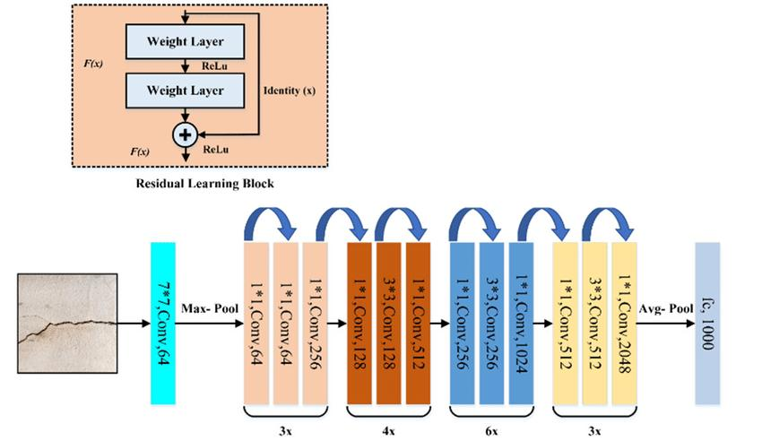
Figure 1: ResNet50 Architecture; illustrating the residual learning block (upper section) and the complete convolutional backbone, which exhibits channel progression from 64 to 2048.

5.2 ResUNet Architecture for Segmentation

ResUNet is a hybrid architecture that combines residual blocks from ResNet with the encoderdecoder structure of U-Net. This design aims to combine the strengths of both architectures: the strong feature extraction and stable gradients of ResNet, and the ability of U-Net to recreate complex spatial details.

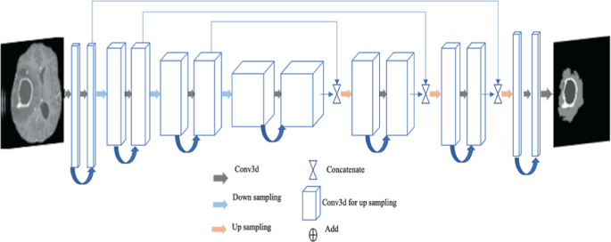
Figure 2: shows the ResUNet encoder-decoder architecture. The left side shows the downsampling process, the middle part highlights the bottleneck, and the right side illustrates the upsampling process, which includes skip connections.

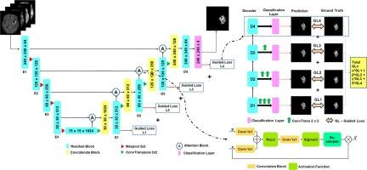
Figure 3: Detailed ResUNet Architecture — depicting residual blocks, attention blocks, guided loss layers (GL1-GL4), and the classification layer.

5.2.1 Encoder Path (Contracting Path)
The encoder's architecture, which is designed to build a hierarchical feature representation, employs residual blocks. These blocks are composed of two 3×3 convolutions, each followed by BatchNorm and ReLU activations, and are connected by an identity skip connection, represented as y = F(x, {Wi}) + x. At each stage, the feature map's depth is increased, progressing from 64 to 128, then to 256, and finally to 512. Simultaneously, 2×2 max-pooling operations are implemented to reduce spatial resolution, thereby enabling the model to capture a more comprehensive contextual understanding.
5.2.2 Bottleneck Layer
At the bottom of the network, the spatial resolution is at its smallest but the feature representation is deepest. This is where the model captures the most abstract information about tumor presence and structure.
5.2.3 Decoder Path (Expanding Path)
The decoder rebuilds the spatial map using ConvTranspose2D layers to upsample progressively. At each stage, skip connections bring in the corresponding encoder feature maps — combining the high-level semantics from the bottleneck with the spatial detail preserved in the encoder. This is how the model produces precise tumor boundaries rather than just blobs.
5.2.4 Attention Mechanism
Standard U-Net treats all regions equally. This model doesn't. Attention gates compute a per-pixel weight: α = σ(Wx^T · x + Wg^T · g + b), where x is the local feature map and g is a gating signal from a deeper layer. The weighted output α·x suppresses irrelevant background and focuses the model's "attention" on likely tumor regions. This is particulary useful for small or irregular tumors.
5.2.5 Multi-scale Guided Loss
Rather than computing loss only at the final output, guided loss layers (GL1–GL4) attach to intermediate decoder outputs. Total loss is: L_total = Σ(i=1 to 4) λi · Li, where each Li is a combination of Binary Cross-Entropy and Dice Loss. BCE handles pixel-level accuracy; Dice handles region-level overlap. Using both at multiple scales forces the model to learn tumor boundaries at different levels of detail.

5.2.6 Sample Output
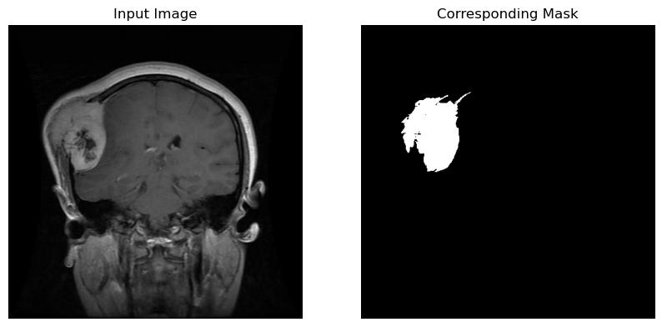
Figure 4: Sample Input MRI and Corresponding Ground Truth Segmentation Mask

5.3 Comparison: U-Net vs ResUNet
Aspect | U-Net | ResUNet
Gradient Propagation | Degrades in deep networks | Stable due to residual identity mappings
Feature Learning | Limited reuse of features | Efficient feature reuse through residuals
Depth | Shallow due to vanishing gradients | Supports deeper architectures
Focus on ROI | Equal weight to all pixels | Attention gates prioritize tumor areas
Loss Design | Single-scale supervision | Multi-scale guided loss enhances accuracy
Boundary Preservation | Moderate | Strong, due to skip and residual fusion

6. Protocol Stack
The table below maps OSI model layers to their roles in this brain tumor detection pipeline:

Layer | Name in This System | Role
Layer 7 — Application | Clinical Interface / Model API | Clinician submits MRI scan; model returns classification and segmentation mask.
Layer 6 — Presentation | Image Encoding & Tensor Conversion | DICOM/PNG files decoded, resized to 224×224, normalized to [0,1], converted to PyTorch tensors.
Layer 5 — Session | Training Session Manager | PyTorch training loop manages epochs, checkpointing, early stopping, learning rate scheduling.
Layer 4 — Transport | Data Pipeline & Batch Transfer | DataLoader batches preprocessed images (batch size 32) and delivers to GPU each iteration.
Layer 3 — Network | Feature Routing (Forward Pass) | Residual blocks route feature maps through encoder, bottleneck, and decoder via skip connections.
Layer 2 — Data Link | Weight Update Mechanism | AdamW computes gradient updates per parameter group with decoupled weight decay.
Layer 1 — Physical | GPU Hardware | NVIDIA GPU executes matrix multiplications and convolution operations for both models.

7. Testbed / Experimental Setup

7.1 Dataset
- Two main datasets were used. For detection (ResNet50), the Kaggle Brain Tumor MRI dataset — 3,482 training images and 447 validation images, binary classification (tumor vs. no-tumor). For segmentation (ResUNet), a subset of BRATS 2018 — 1,992 brain MRI scans.
- Additional datasets were used for the other models: the Figshare CE-MRI dataset (3,064 T1-weighted images, multiclass) and the Harvard Medical dataset (152 images, binary). The Harvard dataset is quite small, which is why results there should be interpreted carefully.

7.2 Model Configuration
Setting | ResNet50 (Detection) | ResUNet (Segmentation)
Base Architecture | ResNet50 (pretrained ImageNet) | ResNet + U-Net hybrid
Optimizer | AdamW | Adam
Loss Function | BCEWithLogitsLoss (weighted) | Dice Loss + BCE (multi-scale guided)
Learning Rate | Dynamic via ReduceLROnPlateau | Fixed / scheduled
Regularization | Dropout p=0.5 + WeightedRandomSampler | Dropout + Batch Normalization
Epochs | 7 (early stopping) | 50
Batch Size | 16 | 32
Peak Test Accuracy | 99.35% | High Dice Score

7.3 Tools and Hardware
Models were built in Python using PyTorch and torchvision. The libraries used included NumPy, OpenCV, Matplotlib, and Seaborn. Data augmentation was done using RandAugment, which included random rotations, flips, and color changes. To handle class imbalance, we used WeightedRandomSampler and a custom BCEWithLogitsLoss function that applied weights to the positive class.

Hardware was a local workstation with an NVIDIA GPU, running Windows (PowerShell environment). Activation functions varied by model component: LeakyReLU and SiLU in the ResNet50 classification head; ReLU throughout the ResUNet encoder and decoder.

7.4 Mathematical Formulation
The training processes relies on:

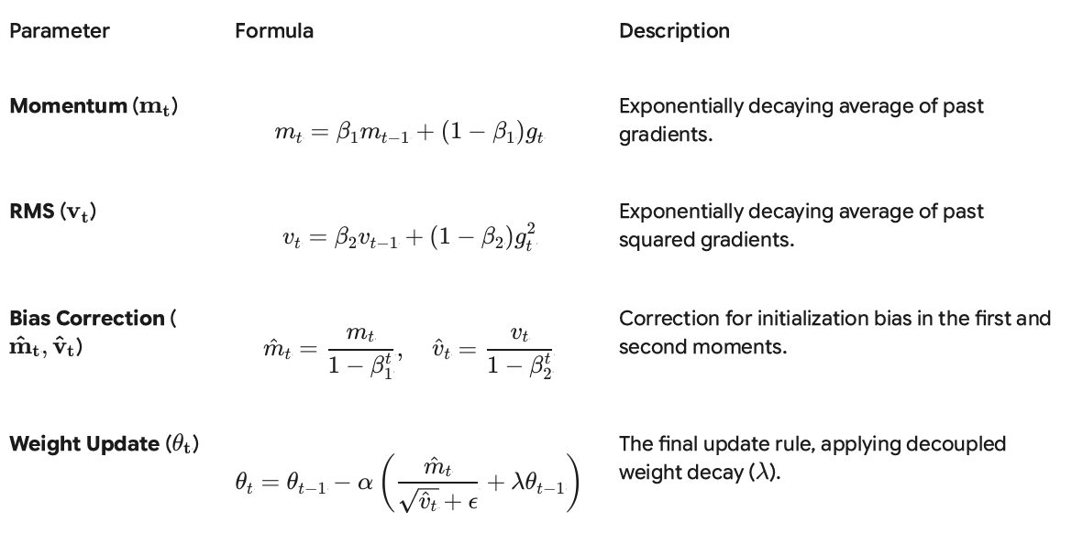
Figure 5: AdamW Optimizer Formulation — Momentum, RMS, Bias Correction, and Weight Update equations

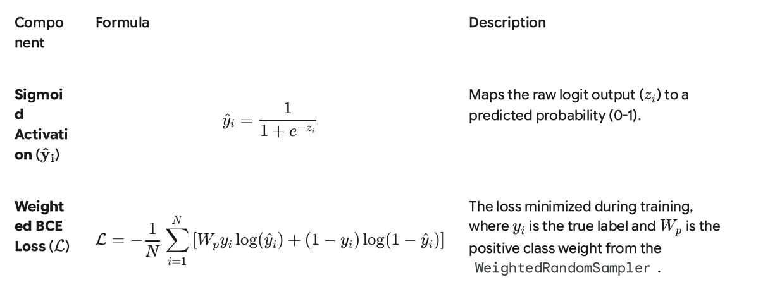
Figure 6: Binary Classification Loss — Sigmoid activation and Weighted BCE Loss function

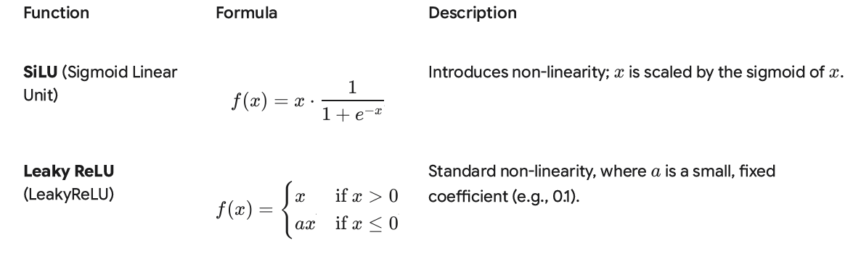
Figure 7: Activation Functions — SiLU (Sigmoid Linear Unit) and Leaky ReLU formulations

8. Implementation

8.1 Comparative Accuracy Over Epochs

Testing accuracy reaches 99.35% at epoch 7. Training accuracy tracked slightly below at 97.2–98.2%. Training loss fell from 0.066 to 0.042; test loss from 0.030 to 0.019. The fact that test loss is consistently lower than training loss and that both fall together without divergence is a good sign — it suggests the regularization (AdamW + Dropout) is doing its job. The model doesn't appear to be memorizing the training set.

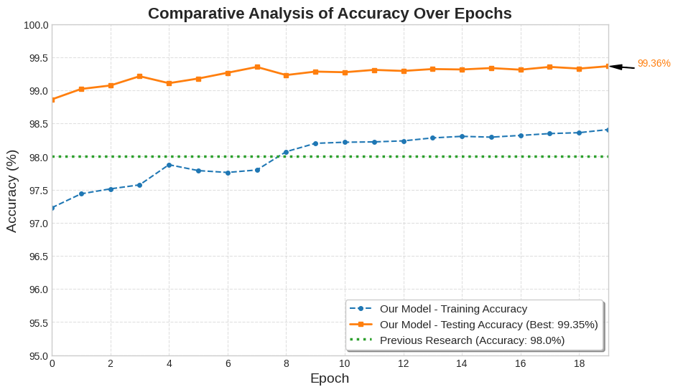
Figure 9: Comparative Accuracy Over Epochs — Training accuracy (blue), Testing accuracy (orange, peak 99.35%), vs Prior Research benchmark ~98% (dotted)

8.2 Confusion Matrix

On the validation set: TP = 198, TN = 379, FP = 3, FN = 9. This gives Precision = 98.5%, Recall = 95.7%, Specificity = 99.2%.
The false positive rate (3 cases flagged as tumor when they're not) is very low, which matters clinically — unnecessary follow-up procedures are costly and stressful for patients. The 9 false negatives are more concerning from a safety standpoint; these are cases where a tumor was missed. In a real clinical deployment, that trade-off between FP and FN would need careful consideration depending on the use case.

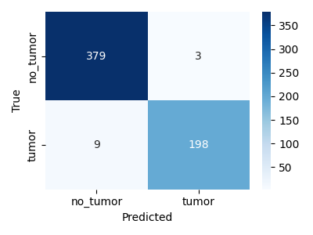
Figure 10: Confusion Matrix — True Positives (198 tumors correctly detected), True Negatives (379 healthy correctly classified), False Positives (3), False Negatives (9)

Key classification metric formulas used:
Metric | Formula | Description
Accuracy | (TP+TN)/(TP+TN+FP+FN) | Overall proportion of correct predictions
Precision | TP/(TP+FP) | Fraction of predicted tumors that are actual tumors
Recall | TP/(TP+FN) | Fraction of actual tumors correctly identified
Specificity | TN/(TN+FP) | Fraction of healthy images correctly classified
F1-Score | 2×(P×R)/(P+R) | Harmonic mean of precision and recall
FPR | FP/(FP+TN) | Proportion of healthy cases misclassified as tumors
FNR | FN/(FN+TP) | Proportion of tumor cases missed by the model

8.3 Segmentation Output Images

Predicted segmentation masks closely match ground truth across test cases, including smaller and irregularly shaped tumors. The attention mechanism seems to genuinely help here; the model doesn't just produce rough blobs but follows actual tumor boundaries. Multi-scale guided loss also appears to make a difference in the finer details.

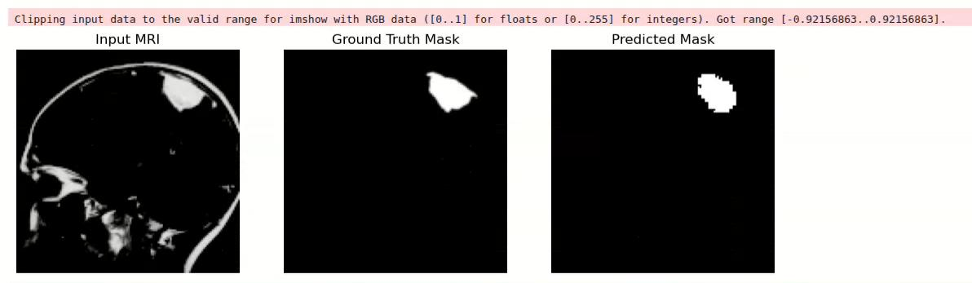
Figure 12: Output Predictions (Set 3) — Input MRI | Ground Truth Mask | Predicted Mask

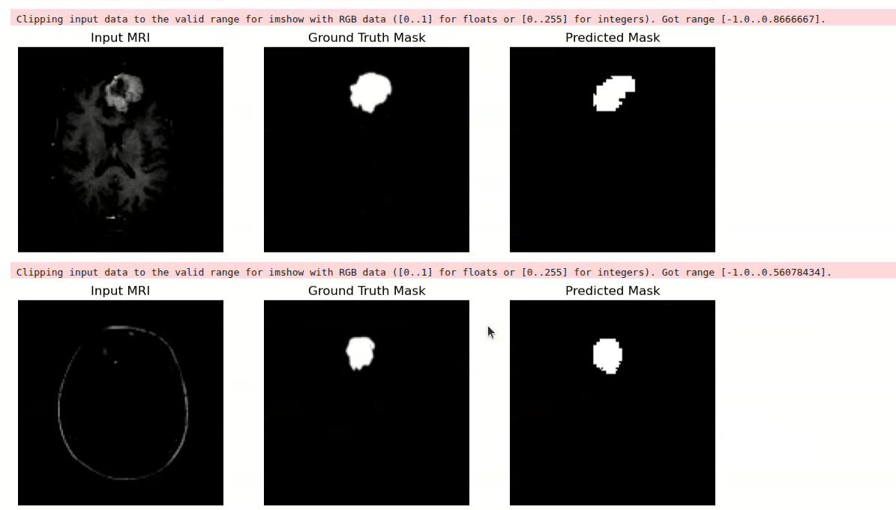
Figure 13: Output Predictions (Set 4) — Input MRI | Ground Truth Mask | Predicted Mask

Observation: The predicted masks show a strong similarity to the ground truth in all test cases, including those with irregular and small tumors, thereby proving its effectiveness.

